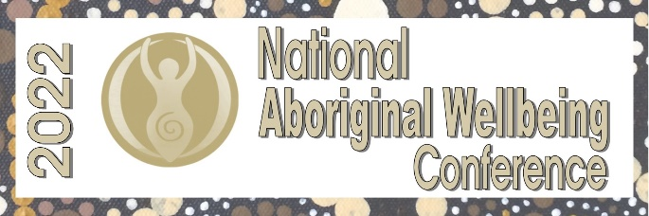

WORKSHOP
Expression of Interest
MUST BE SUBMITTED BY 30 May 2022

Workshop Presenter Details
Name -
Organisation -
Contact phone number –
Email address –

Workshop Presenter Bio
Speaker Bio (100 words)

Topic details
Name of Workshop -
Describe the topic – (150 words)

Proposal commitment
Do you agree to the following – YES / NO
In submitting a proposal, you are committing to meeting the NAWC deadlines, including:
Free registration will be offered to ONE presenter only – Travel, meals and accommodation are at the cost of the presenter
•Finalising all workshop details in time for the marketing of the conference by 17 June 2022
•Submission of workshop presentations by 29 July 2022
•Possible peer review where required.

Signature Date
_______________________________________________ ___________________________

Please visit www.aboriginalwellbeingconference.com
Or
Contact Shannon May – shannon@spiritdreaming.com.au
Ph – 0417 643 804

